**Chbe 4400 Project 1**

Group 1

Jiyuan Ding

Junxian Wu

Zongzhe Xue

1. Balances

Mass Balance:

(1)

Linearization for later use:

At steady state:

Finally:

(2)

If Steady State:

Since outflow mass must equal to inflow mass, we have:

Energy balance:

(3)

Linearization:

At steady state:

Finally:

(4)

Equation for h:

(5)

At steady state:

(6)

2. Operating temperature plot:

Use mass balance to substitute C2:

Plug C2 in the Qreaction:

(7)

(8)

Evaluate eq (7) and (8) in Matlab, we get the following graph:

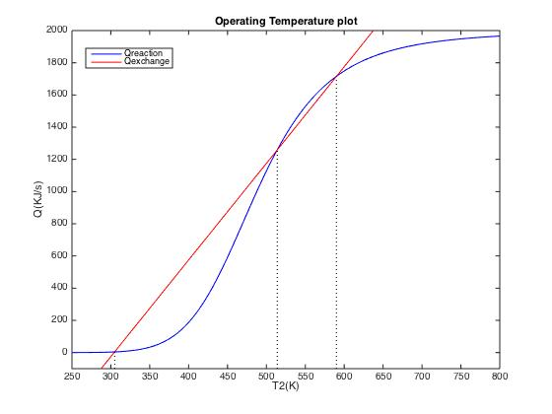

The highest operating temperature is about 590K.

3. Feed rate change response

By defining the nonlinear equations (1), (3) and (5) in Matlab and feeding them to an ode45 solver, the response of outlet concentration, temperature and liquid level was computed and represented in the following three images. Matlab code can be seen in appendix.

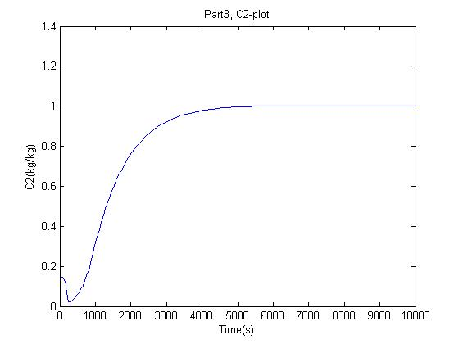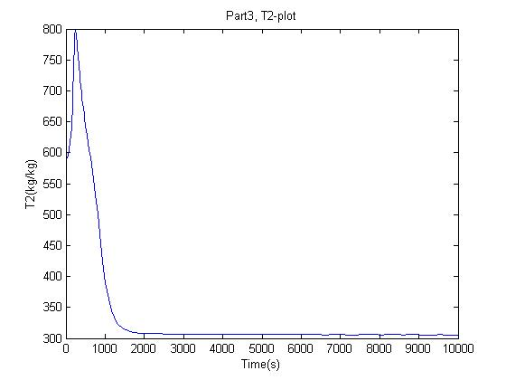

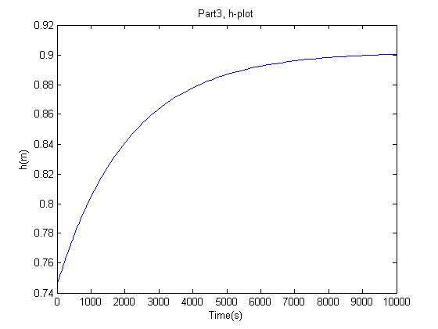

4. Feed temperature change response

Similarly, the outlet concentration and temperature response to a feed temperature change was computed and shown in the following two images.

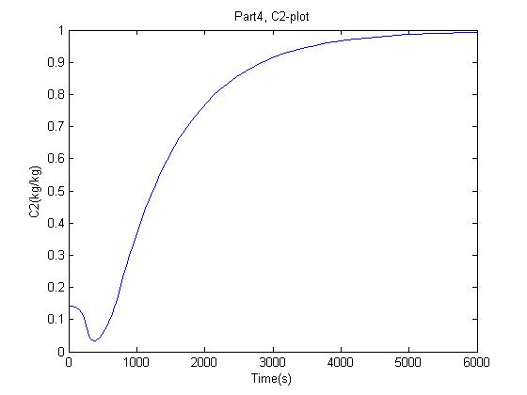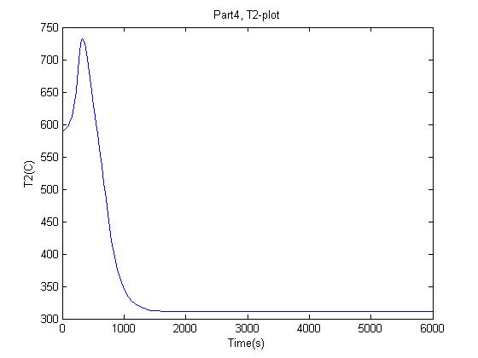

5. Cooling temperature change response

With the same method as part 3 and 4, the outlet concentration and temperature response are shown in the following two images.

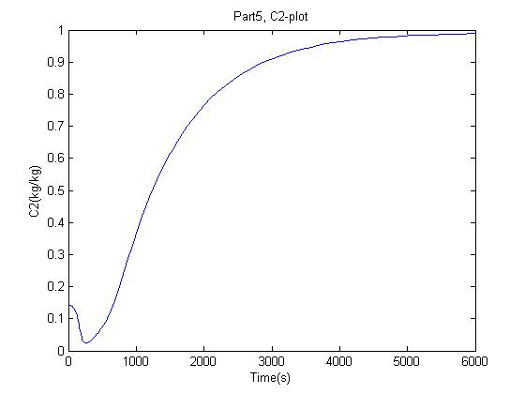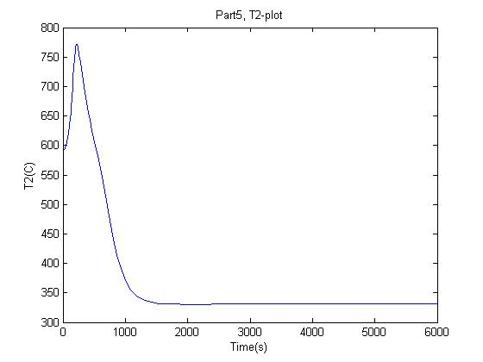

6. State space representation:

State variables:

Input variables: [u]=[

Rearranging equation (2), (4) and (6), we get the following state-space representation:

= + [][]

7. Simulink

Compared to part 3:

Compared to part 4:

Compared to part 5: